**LAB # 06**

**Task # 01: Write a program which contains a class ‘Calculator’ contains multiple sum method by using method overloading concept.**

**Solution:**

**public static void main(String[] args)** {

Calculator obj=new Calculator();

obj.sum(2,3);

obj.sum(2,3,4);

}

**public class Calculator** {

public void sum(int a, int b) {

int sum = a + b;

System.out.println("Sum of two numbers = " + sum);

}

public void sum(int a, int b, int c) {

int sum = a + b + c;

System.out.println("Sum of three numbers = " + sum);

}

}

**Output:**

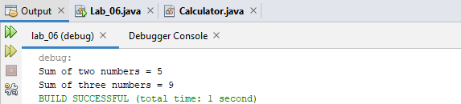

**Task # 02: Create a class to print the area of a square and a rectangle. The class has two methods with the same name but different number of parameters. The method for printing area of rectangle has two parameters which are length and breadth respectively while the other method for printing area of square has one parameter which is side of square.**

**Solution:**

**public static void main(String[] args)** {

Area obj=new Area();

obj.area(4);//square

System.out.println("----------------------------------------\n");

obj.area(3, 4);//rectangle

}

**public class Area** {

public void area(int side) {

System.out.println("AREA OF SQUARE");

int area = side * side;

System.out.println("SIde = " + side);

System.out.println("\nAREA OF SQUARE = " + area);

}

public void area(int length, int breath) {

System.out.println("AREA OF RECTANGLE");

int area = length * breath;

System.out.println("Length = " + length);

System.out.println("Breath = " + breath);

System.out.println("\nAREA OF RECTANGLE = " + area);

}

}

**Output:**

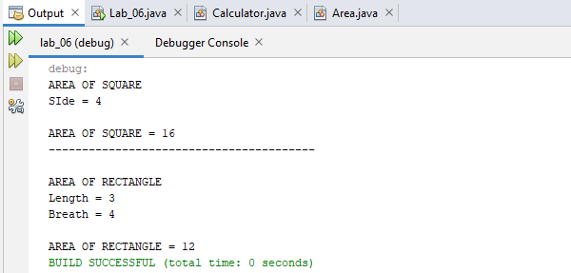

**Task # 03: Create a class 'Student' with three data members which are name, age and address. The constructor of the class assigns default values name as "unknown", age as '0' and address as "not available". It has two members with the same name 'setInfo'. First method has two parameters for name and age and assigns the same whereas the second method takes has three parameters which are assigned to name, age and address respectively. Print the name, age and address of 4 students**.

**Solution:**

**public static void main(String[] args)** {

Student s1=new Student();

Student s2=new Student();

Student s3=new Student();

Student s4=new Student();

System.out.println("----------STUDENT 01 -----------");

s1.SetInfo("ali", 17, "malir");

System.out.println("----------STUDENT 02 -----------");

s2.SetInfo("ahmed", 15, "cantt");

System.out.println("----------STUDENT 03 -----------");

s3.SetInfo("ammar", 19);

System.out.println("----------STUDENT 04 -----------");

s4.SetInfo("asad", 19, "karsaz");

}

**public class Student** {

String name, address;

int age;

public Student() {

String name = "ahsan";

int age = 0;

String address = "";

}

public void SetInfo(String name, int age) {

System.out.println("NAME = " + name);

System.out.println("AGE = " + age);

System.out.println("ADDRESS = "+address);

}

public void SetInfo(String name, int age, String address) {

this.name = name;

this.age = age;

this.address = address;

System.out.println("NAME = " + name);

System.out.println("AGE = " + age);

System.out.println("ADDRESS = " + address);

}

}

**Output:**

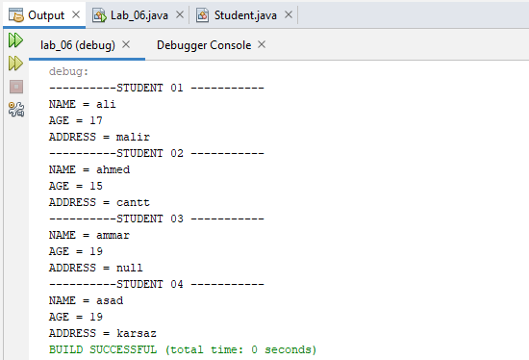

**Task # 04: Implement the Circle class to overload the + operator so that you can add two Circle objects. Adding two Circle object should give another Circle whose radius is the sum of the radii of the two Circle objects.**

**Solution:**

**static void Main(string[] args)** {

radius rad1 = new radius(5);

radius rad2 = new radius(2);

Console.WriteLine("------------RADIUS 01 --------------");

Console.WriteLine(rad1.getlength());

Console.WriteLine("------------RADIUS 02 --------------");

Console.WriteLine(rad2.getlength());

radius rad3 = rad1 + rad2;

Console.WriteLine("------------ SUM --------------");

Console.WriteLine(rad3.getlength());

Console.ReadLine();

}

**class radius**{

int radi;

radius()

{

radi = 0;

}

public radius(int radi)

{

this.radi = radi;

}

public string getlength()

{

return string.Format ("RADIUS : {0}", radi);

}

public static radius operator +(radius r1,radius r2)

{

radius r3 = new radius();

r3.radi = r1.radi + r2.radi;

return r3;

}

}

**Output:**

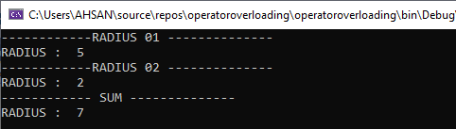

**Task # 05: Implement the Rectangle class to overload the + operator so that you can add two Rectangle objects. Adding two Rectangle objects should give another Rectangle object whose length is the sum of the lengths of the two Rectangle objects and whose breadth is the sum of the breadths of the two Rectangle objects.**

**Solution:**

**static void Main(string[] args)**{

rectangle rec1 = new rectangle(4,5);

rectangle rec2 = new rectangle(2,3);

rectangle rec3 = rec1 + rec2;

Console.WriteLine("------------ rectangle 01 ---------------");

Console.WriteLine(rec1.getlengthbreath());

Console.WriteLine("------------ rectangle 02 ---------------");

Console.WriteLine(rec2.getlengthbreath());

Console.WriteLine("------------ rectangle 03 ---------------");

Console.WriteLine(rec3.getlengthbreath());

}

**class rectangle**{

int length, breath;

public rectangle()

{

this.length = 0;

this.breath = 0;

}

public rectangle(int length,int breath)

{

this.length = length;

this.breath = breath;

}

public string getlengthbreath()

{

return string.Format("RECTANGLE = length : {0} , breath : {1}", length, breath);

}

public static rectangle operator +(rectangle r1,rectangle r2)

{

rectangle r3 = new rectangle();

r3.length = r1.length + r2.length;

r3.breath = r1.breath + r2.breath;

return r3;

}

}

**Output:**

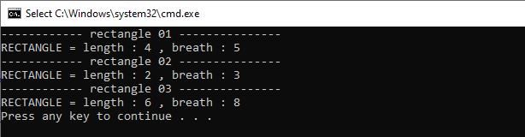

**Task # 06: Write a class Time which represents time. the class should have three fields for hours, minutes and seconds. It should have constructor to initialize the hours, minutes and seconds.  
A method printTime() to print the current time.  
Overload the following operators:  
plus operator (+) (add two time objects based on 24 hour clock)  
and < (compare two time objects)**

**Solution:**

**static void Main(string[] args)**{

time rec1 = new time(2, 35, 49);

time rec2 = new time();

rec2.printtime();

rec2 = new time(rec2.hour,rec2.min,rec2.sec);

time rec3 = rec1 + rec2;

Console.WriteLine("------------ time 01 ---------------");

Console.WriteLine(rec1.gettime());

Console.WriteLine("------------ time 02 ---------------");

Console.WriteLine(rec2.gettime());

Console.WriteLine("------------ time 03 ---------------");

Console.WriteLine(rec3.gettime());

}

class time

{

public int hour, min, sec;

public time()

{

this.hour = 0;

this.min = 0;

this.sec = 0;

}

public time(int hour, int min, int sec)

{

this.hour = hour;

this.min = min;

this.sec = sec;

}

public void printtime()

{

DateTime dt = DateTime.Now;

hour = dt.Hour;

min = dt.Minute;

sec = dt.Second;

}

public string gettime()

{

return string.Format("TIME = {0}h : {1}m : {2}s", hour, min, sec);

}

public static time operator +(time t1, time t2)

{

time t3 = new time();

t3.sec = t2.sec + t1.sec;

t3.min = t2.min + t1.min;

t3.hour = t2.hour + t1.hour;

if (t3.sec >= 60)

{

t3.sec -= 60;

t3.min++;

}

if (t3.min >= 60)

{

t3.min -= 60;

t3.hour++;

}

return t3;

}

**Output:**

